**Identify the system constraints and define criticality**

1. **Availability.**
   1. The **Server** up-time should be greater than 95% of all time.
   2. Maximum number of simultaneously **connections** couldn’t be greater **100 clients** at the same time.
   3. The response time couldn’t be greater 30 second for **clients.**
   4. The **Server** couldn’t be outage more than 2 times per month with outage times greater than 10 minutes.
2. **Detected failure.**
   1. Maximum acceptable **interruption for accessing and browsing data** couldn't be greater than 50 times per month for a 10 minutes of filling data worth.
   2. Every week must be created a **backup** on **hot-replacement media drive**.
   3. The **Server** should be restarted after critical failure no more than in 1 hour.
   4. Any failure should be logged.
3. **Bandwidth.**
   1. The average speed for:  
      **1-20 users** (at the same time) - **>50mbps  
      20-50 users - >20mbps**  
      **50-100 users - >10mbps**
4. **Accessibility.**
   1. Only **authenticated users** can **access and browse** the data.
   2. If the personal **data is blocked** then this data will not appear during the browsing.
5. **Data volume.**
   1. The **Server** capacity should be greater or equal **10TB of personal data**.
   2. All **critical data** on the server must have a **backup**.
6. **Internet.**
   1. The **Internet** bandwidth should be at least **Gigabit Ethernet**.
   2. For **connection** to the server only **FTP** could be used.
   3. **FTP server** should be able to manage accessing.

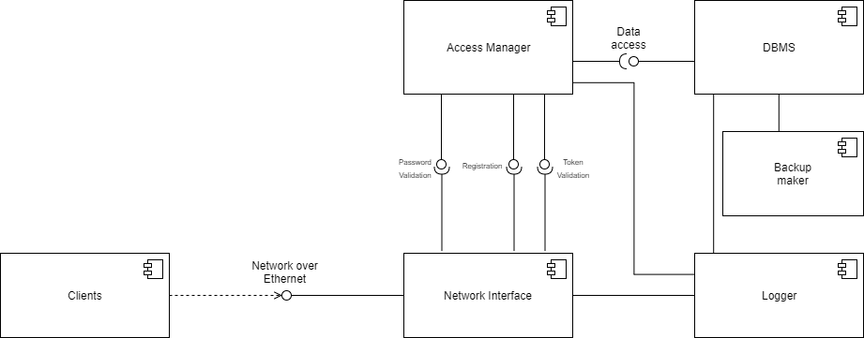**Design an Architectural configuration (Components and Connectors) compatible with the System Constraints.**

**Perform the High-Level Design for the 3 possible hardware configurations**

I really don’t know, what did you exactly mean by “hardware configurations”. The system architecture doesn’t change for any type of clients. If it was different types of clients then there is no way to determine which type of client is connected, whether it mobile, desktop or web application as FTP is the same for every type of devices. So, we can only make assumptions that from the mobile we have slower bandwidth, limited data usage. Desktop client could be characterized by high speed and stable connection, unlimited download/upload. Also, clients could choose by your own which application/browser they would use for connection via FTP protocol.

If it was meant to server hardware then server could be running on different types of hw. But this hardware must satisfy system’s constraints. And again, replace some component in architecture doesn’t change it in overall (e.g. we can use MySQL, SQLite or any other as DBMS but it will work until it provides properly interface).

It’s my opinion. Do not judge too strong if it possible.